**Avengers Data Set Power Calculations and Preliminary Analysis – Assignment 1**

Nicole Ponto (B00871580)

Department of Psychiatry, Dalhousie University

PSYR 6003: Statistics

Dr. I. Yakovenko

March 7, 2024

**Results**

The data set ‘Avengers’ was taken from Github and inspected for missing and unusual values using various filtering techniques. The data set was arranged to have ID numbers, and two datasets contained missing or unusual values, but these were removed. A custom variable was created called ‘combatEffectivness’ which consists of the sum of agility, speed, strength, and willpower for all participants. After the variable was created, SPSS and csv formatted files were saved for a subset of the data that contained avengers who did not have superpowers and have died.

This dataset titled ‘bad_avengers’ was summarized to describe the properties of combat effectiveness. The dataset contained another variable separating the avengers into either north or south battlefields, to gain a better picture of the properties above they were again summarized to represent battlefield locations as well. These properties were represented through a mean (M), standard deviation (SD), and range (R), combat Effectiveness (North - M=499.78, SD=174.06, R= 766.38, South – M= 491.68, SD= 189.52, R =879.64), kills (North - M=1.71, SD=4.57, R=34, South – M = 4.75, SD=14.99, R= 79 ), and injuries (North - M=4.60, SD=0.68, R=3, South – M= 4.42, SD=0.87, R=3).

Based off the properties observed above, and the visualizations performed using a ‘ggplot’ package the battlefield that was most effective in combat was the north battlefield (See Appendix A). The north battlefield also had the most injuries. Based off the variables observed the most erroneous mean model was the error of kills.

A secondary analysis is to be performed to understand the relationship between having superpowers and IQ. Before analysis can be done, the breadth and size of the sample must first be considered. Two justifications were considered when looking at the avenger's data sample, the first consideration looked at the smallest effect size of interest (SESOI). In this dataset, where there is no prior research or literature in the area, taking into consideration what would be needed for a finding to be relevant in its field will help to guide decisions. This can further be guided based on the resources available and the notion that the effect should be a noticeable effect in its respected area. As there is currently no data in this area, it was assumed by the researchers that a medium effect size would generate information for the interests of this data set. There was a second justification considered, and it was the effect size, and what would make it minimally statistically detectable. In an area where there is no prior literature or research an effect size of d= 0.5 would prove statistically detectable if there was something to be detected.

A medium effect size (d=0.05) was chosen and used for the rest of the analysis.

In a two-sample t-test power calculation the sample was powered for a medium effect size (d=0.5), with an alpha level of 0.05 and a power of 85%. The calculation found that 73 participants were needed per group to obtain a medium effect size with 85% power. An alpha level of 0.05 was chosen to indicate a 5% chance of rejecting the null hypothesis, which given the novelty of the data, seemed to reliably be able to reflect any subtleties in the data. A power of 0.85 was chosen to indicate with a high level of certainty if true effects exist.

To ensure that power accounts for the zero effect between groups a two sample TOST power calculation comparison was performed (alpha = 0.05, power = 0.85) which calculated an n of 20 required per group to power the effect size.

After carrying out the study and performing a t-test (t=4.24, n=812), using the test statistic and sample obtained an effect size and confidence interval were calculated ( d= 0.30 [0.16, 0.44]). This effect size falls between small and medium effect sizes in Cohen's quantitative conventions and is noticeable but not particularly strong. With the large sample size (n=812) , the assumption that this data was collected in a highly controlled way (limiting variability), and the novelty of these analyses in the avengers data field, the estimate has been deemed precise.

**Appendix A**

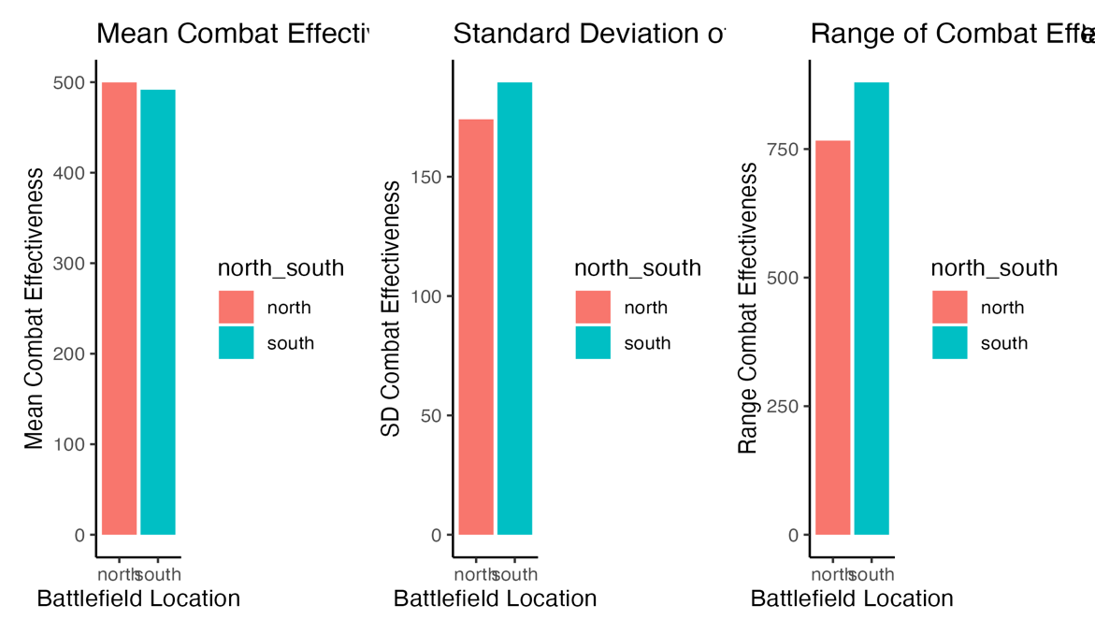

Figure A1. Analysis of Combat Effectiveness compared across battlefield locations. Analyses done for mean, SD, and range.

Figure A2. Analysis of combat effectiveness and mean total battle injuries across battlefield locations.

Figure A3. Analysis of injuries compared across battlefield locations. Analyses done for mean, SD, and range.

Figure A4. Analysis of kills compared across battlefield locations. Analyses done for mean, SD, and range.

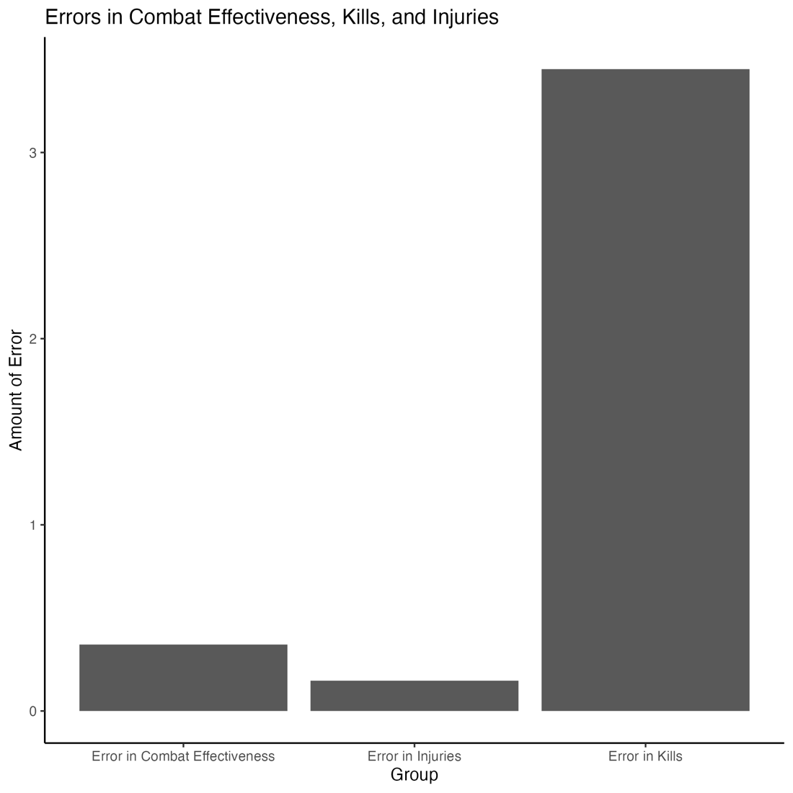

Figure A5. Analysis of most erroneous model across combat effectiveness, injuries, and kills. Calculated using mean/SD.

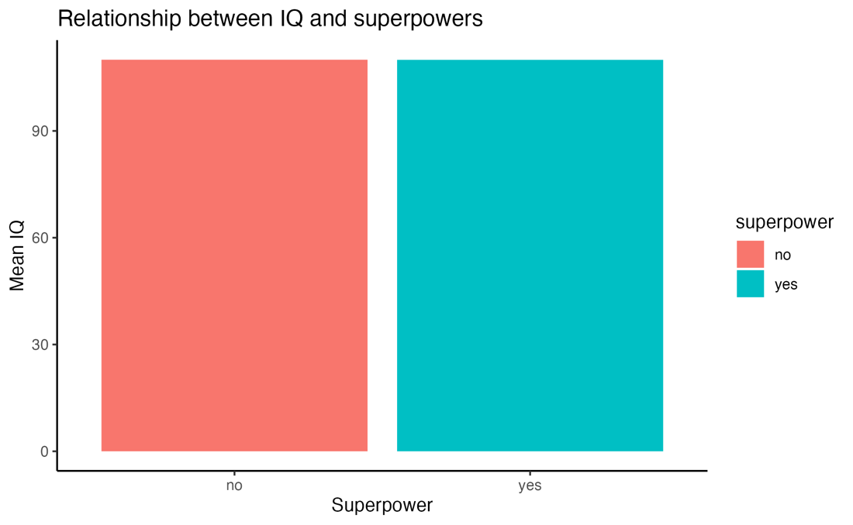

Figure A6. Relationship between IQ and superpowers using mean IQ.